The Simlog application is the replacement for the Sim Logbook function of ATOM.

Start by selecting the SimLog icon from the Start Menu Start>SWA Apps>OQS SimLog or from the Icon on the desktop. This will open an Internet Explorer session and present the login screen.

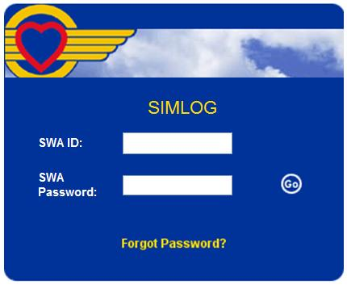

Enter your standard SWA login employee number (exxxxx) and current password to login.  
You’ll be directed to the Home screen:

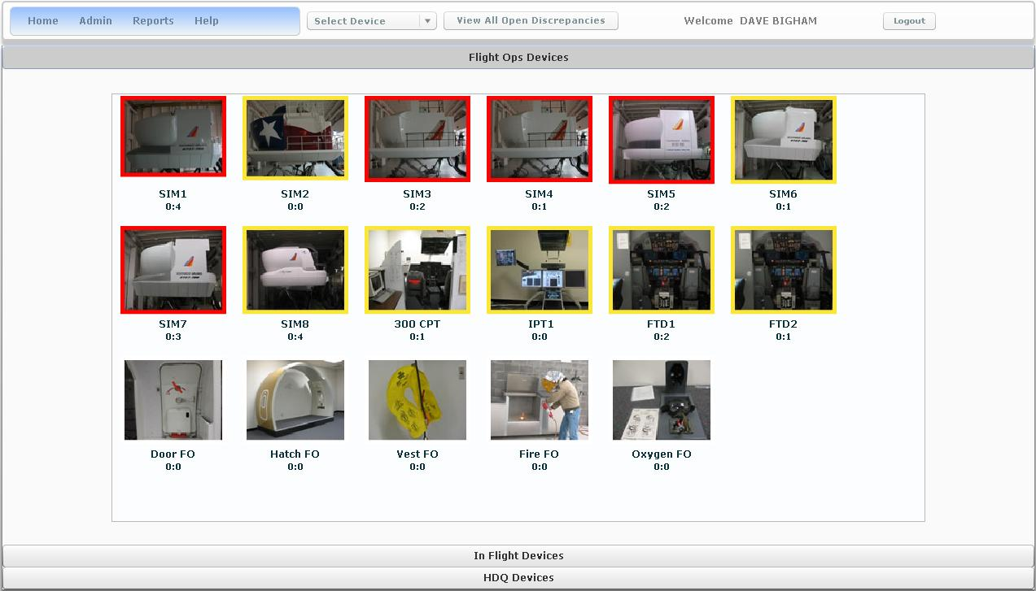

The numbers below each device display the number of open discrepancies for the device. The first number displays the number of new discrepancies entered within the current 4 a.m. – 4 a.m. 24 hour cycle that remain open. The second number displays total open.   
**Note:** These numbers are only displayed for Sim Techs. They are not displayed for Sim Instructors and Check Pilots.

The following is a sample scenario for SIM8 explaining how the system determines the values displayed below each device.

|  |  |  |  |  |  |
| --- | --- | --- | --- | --- | --- |
| **Time / Date** | **User Action – for Sim 8** | **New / Still Open** | **Old / Open** | **Total Open** | **Values displayed on home page** |
| 0401 / March 2 | None | 0 | 4 | 4 | 0:4 |
| 0800 / March 2 | New Discrepancy is opened | 1 | 4 | 5 | 1:5 |
| 1100 / March 2 | New Discrepancy is opened | 2 | 4 | 6 | 2:6 |
| 1500 / March 2 | One of the old discrepancies is closed | 2 | 3 | 5 | 2:5 |
| 1700 / March 2 | One of the new discrepancies is closed. | 1 | 3 | 4 | 1:4 |
| 0401 / March 3 | None | 0 (value resets) | 3 | 3 | 0:3 |

The color code for the border of the device icons are as follows:

Green – Preflight Complete and the Device Status is UP

Yellow – Device is available for Preflight and Status is UP

Red – Device Status is DOWN

No Border – Device Status is not applicable

The default Device tab is Flight Ops Devices. At the bottom of the page are tabs for In Flight Devices and HDQ Devices. Selecting the In Flight Devices tab will show icons for all Door, Vest and Mask Trainers, sorted by device type. Selecting the HDQ Devices tab will show icons for all devices, Flight Ops and In Flight, located on the Headquarters Campus.

Selecting a device from the home screen will take you to the summary page for the selected device. To return to the Home screen, select the Home iconHome Icon.JPG, at the top of the page.

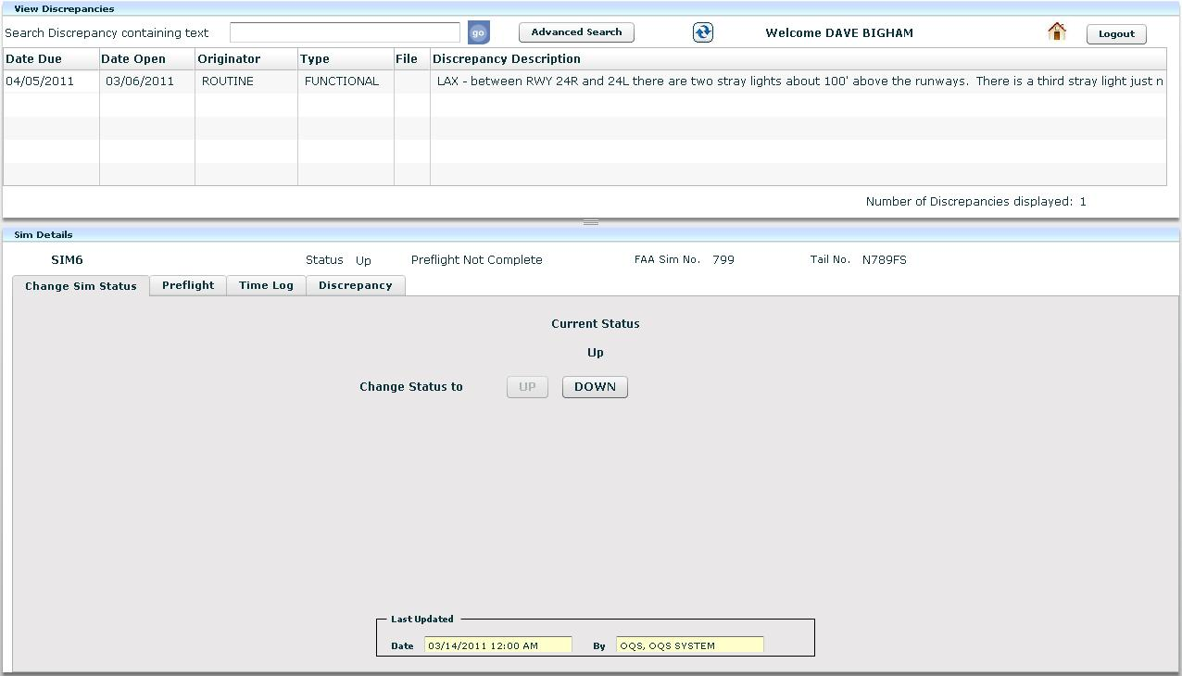

The top pane displays all open discrepancies. The presentation can be sorted by selecting the field description at the top of the column, with the exception of the discrepancy description. The bottom pane is for changing sim status, preflight, crew training time log and adding/viewing discrepancies.

**Discrepancies:**

Selecting an existing discrepancy from the top pane will open the discrepancy tab and show the details of the selected discrepancy.

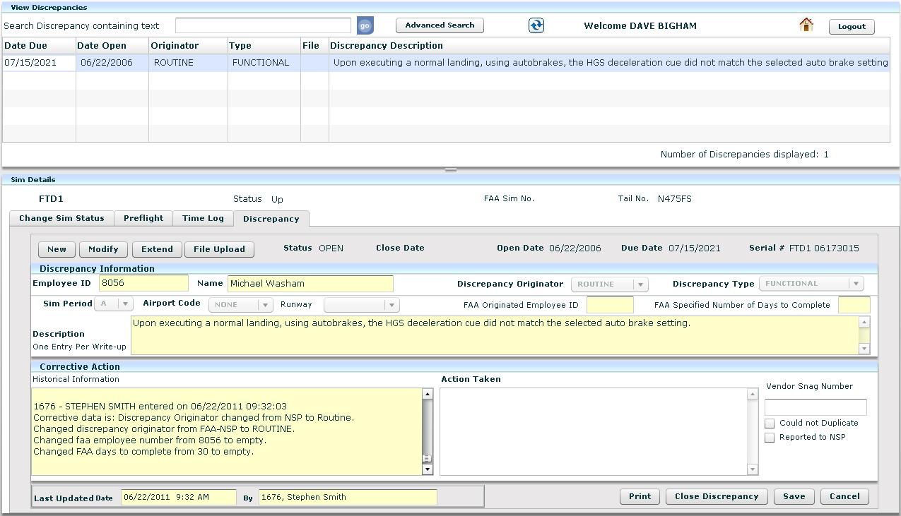

At this point the Action Taken field at the bottom is open for edit and this where any work notes would be added.

Selecting the Print button will generate a single page report that can be printed or saved.

The close discrepancy, save or cancel buttons can also be selected.

Any data saved will be shown as the last entry in the Historical field and the Last Updated Date fields will be updated to reflect the change.

Uploading an Attachment to a discrepancy:

Selecting the File Upload tab allows for attaching a secondary document (1mb limit). It will open an explorer window starting at the desktop level and allow navigation to any drive associated with the target computer. After selecting the file to upload, the attached file icon appears adjacent to the file upload button. To view the file(s) attached to a discrepancy, select the paperclip icon from the discrepancy detail pane and the attachment will open in a separate browser window. If there are multiple files attached to the discrepancy, a dialogue box will appear to allow you to select which file to view.

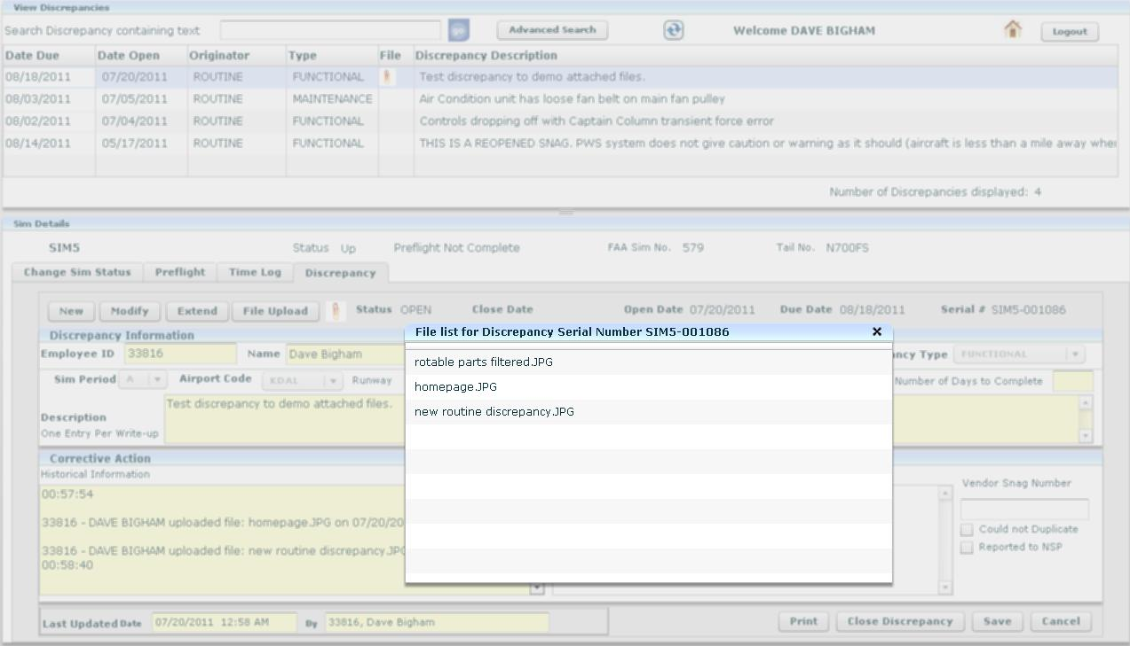

Adding a New Discrepancy:

To add a new discrepancy, select the “New” tab and the employee ID and name will auto fill based on your login information.

The Discrepancy Originator field is new. The vast majority of the originators will be classified as routine. The FAA originators will be classified as FAA-NSP, FAA-CMO or FAA-Other. 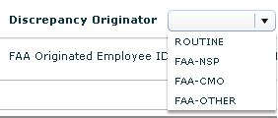

If any of the FAA originator selections are made, the FAA Originated Employee ID will fill with your ID number and the FAA Specified Number of Days to Complete field will turn white, requiring data.

Another new field is the Discrepancy Type. The majority of discrepancies will be classified as Functional, but we have the ability to create discrepancies that will only be viewable by maintenance personnel.

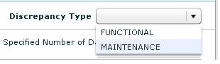

Typical Maintenance Discrepancies would include failing QTG tests, follow-up PM items, etc. When an instructor/Check Airman logs into SimLog, Maintenance Discrepancies will not appear on the Discrepancies summary.

The Sim Period, Airport Code and Description will need to be selected prior to saving the discrepancy.

If any mandatory fields are not filled, an error box will pop up, listing the required fields.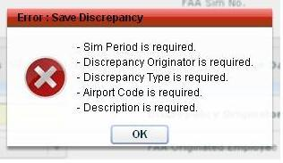

Creating / Updating an FAA-NSP Discrepancy:

The following actions will generate an email to a designated email group (e.g. SIMTECH-DG, Manager of Quality Assurance and Regulation).

1) Open an FAA-NSP discrepancy

2) Extend an FAA-NSP discrepancy

3) Close and FAA-NSP discrepancy

Note: the following actions can only be completed by the Manager of the Sim Tech group and other Managers with access to these functions.

4) Change a discrepancy from FAA-NSP to another originator

5) Change the Type for an FAA-NSP discrepancy

6) Change a discrepancy to an FAA-NSP originator.

The following is a sample of the email that will be generated:

-----Original Message-----  
From: OQSTeam-DG   
Sent: Tuesday, July 19, 2011 7:47 AM  
To: Jim Ratcliff; Stephen SIMTECH-DG  
Subject: FAA-NSP Discrepancy has been CLOSED  
Importance: High

Following are the details of the FAA-NSP Discrepancy that has been Closed:

Serial Number: HATCH MDW-000002

Created By: 33816, DAVE BIGHAM

Create Date: 07/19/2011

Due Date: 08/17/2011

Type: FUNCTIONAL

Discrepancy Description: does it create an email??

Closed By: 33816, DAVE BIGHAM

Closed Date: 07/19/2011

**Reports:**

Selecting Reports from the Home screen yields two submenus, Device and Inventory Reports.

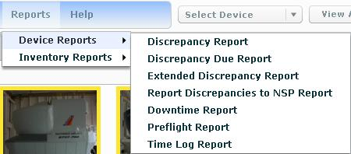

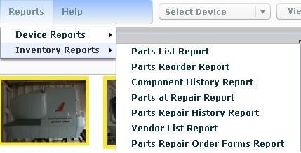

Selecting a report will pop the report detail window. All fields must have a valid selection to produce the report.

This is an example of the Discrepancy Report

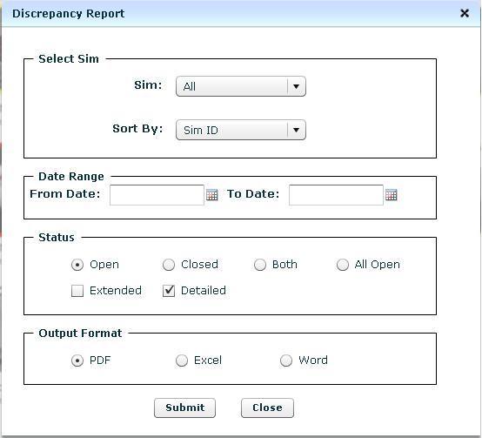

The resulting report will open in another Internet Explorer window and can be directly searched, printed, saved or emailed.

This is an example of the Parts List Report:

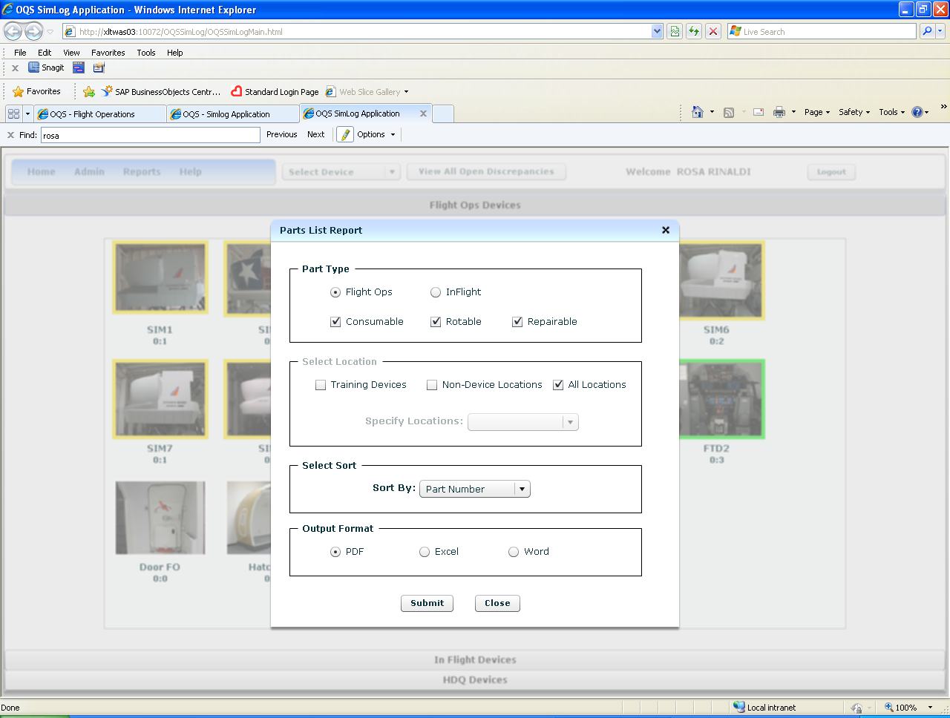

**Parts and Components:**

Parts and Components are accessed by selecting the function below the Admin tab:

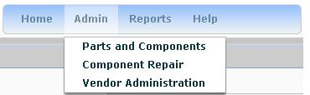

And will present the Simlog Parts and Components Home Page:

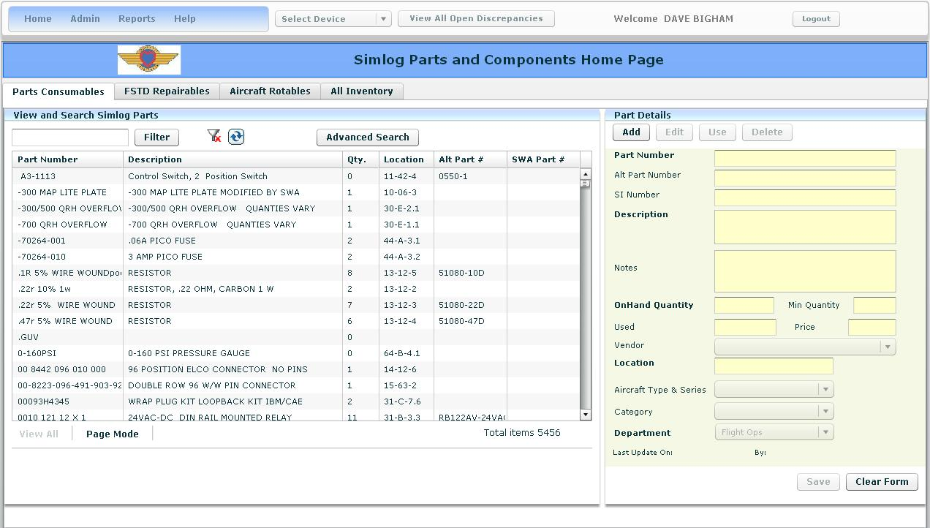

Selecting any of the category headers will sort the presentation by the selected field. (i.e. selecting the Description field will sort the display alphabetically, in ascending order). Selecting the same field again will sort the results in descending order.

There are four tabs available from the Parts and Components Home Page; Parts Consumables, FSTD Repairables, Aircraft Rotables and All Inventory. The examples are taken from the Parts Consumables tab, but the basic functionality of the View and Search Parts pane is identical.

The All Inventory tab will display all parts contained in the database.

The fields displayed for the Part Details pane varies by category.

To add a part, from the Part Details pane, select the Add button:

The Fields in bold are required data for adding a record.

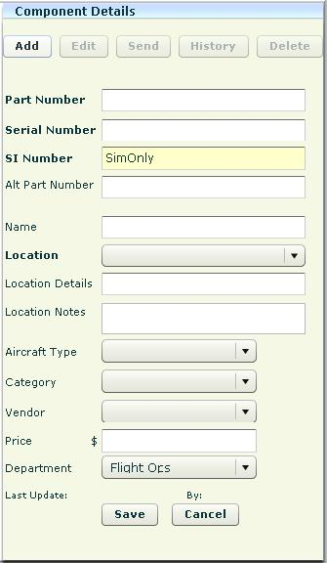

Deleting a record removes the record from the database and is not recoverable.

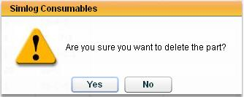

Selecting the history button will display the location movement of the selected component.

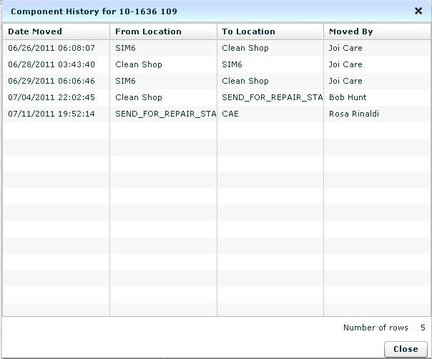

To filter the display by all records containing a character string, type the desired text (location, part number, description, etc…) and select Filter.

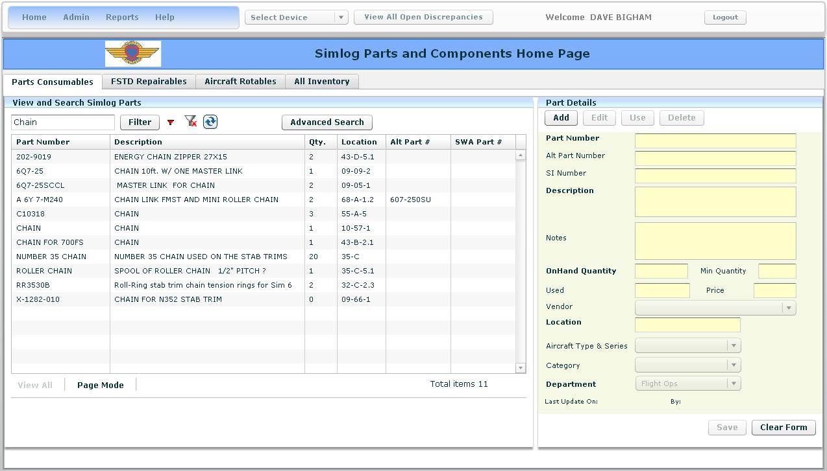

The red filter icon filter.JPGwill appear next to the filter button, indicating the display has been filtered. Selecting the white filter icon filter remove.JPG will remove the filter and result in the previous display. Selecting the Refresh icon Parts and Components refresh.JPG will remove any filters and sorting actions.

When the All Inventory tab is selected, a second filter field is enabled. This allows you to apply a second filter to the records produced from the first filter activity.

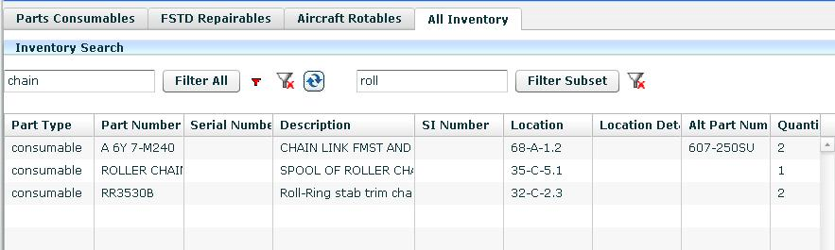

Also on the All Inventory tab, the Details screen provides some of the basic functions dependent on the part type selected.

If you select a Consumable part, the Use Part button is enabled. If you select an FSTD Repairable or an Aircraft Rotable component, the Edit Loc and History button are enabled.

If you select Edit Loc for an FSTD Repairable component, you can change to Location to or from a device, to or from Sim Stores, and so forth. You can also select the Location of “SEND_FOR_REPAIR_STAGING” this will “move” the component from the normal stock inventory to the Out for Repair inventory. The item location will now indicate “SEND_FOR_REPAIR_STAGING” and the component details are no longer editable until it has completed the repair cycle.

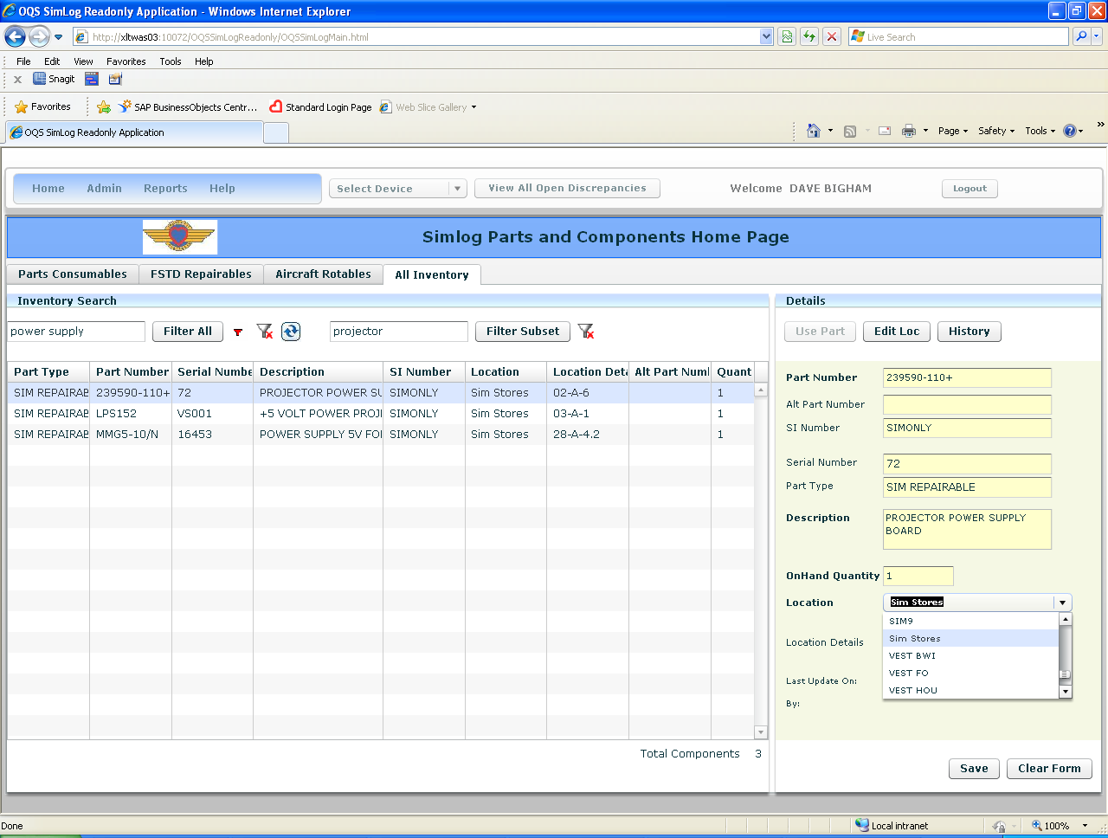

The Advanced Search allows greater flexibility, but is only available for the Parts Consumables tab.

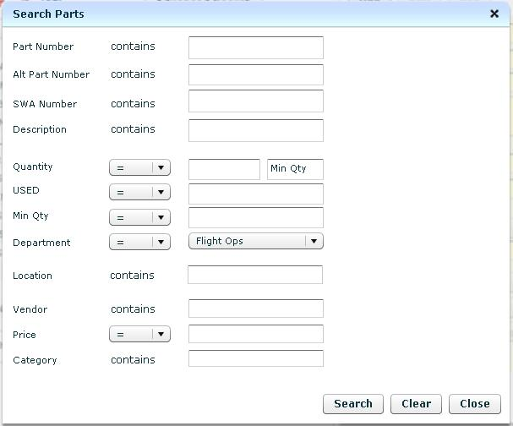

Sample FSTD Repairable view:

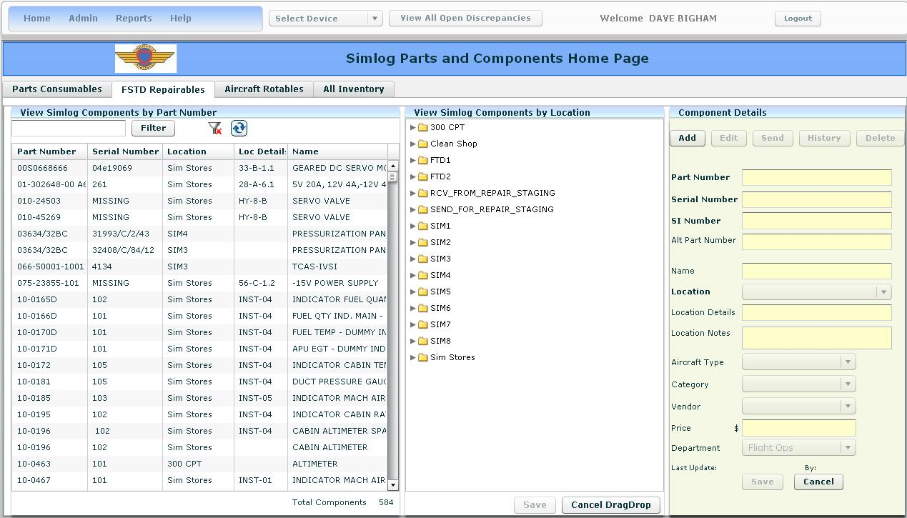

Sample Aircraft Rotables view:

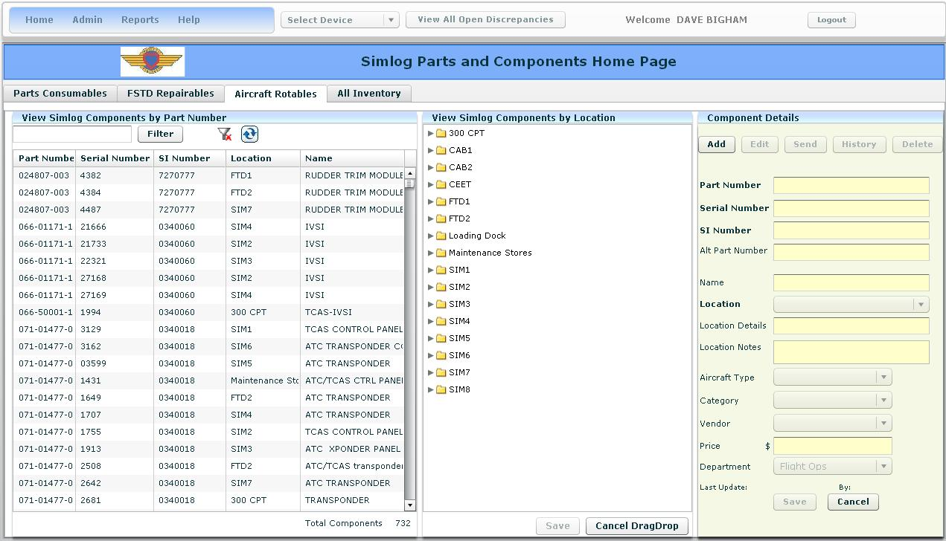

Both the FSTD Repairable and Aircraft Rotables views have a View Simlog Components by Location pane that will indicate all components currently residing in a particular location/device.

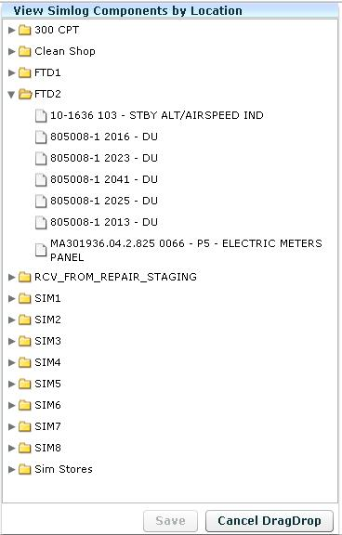

You can manipulate parts locations using traditional windows “drag and drop” functionality and selecting Save. The Cancel DragDrop button will reset the view without saving.

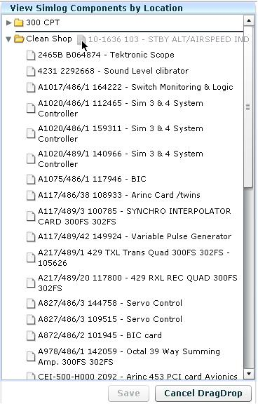

To replace an FSTD Repairable, select the part from the Part Number pane. This will populate the Component Details Pane and enable the Edit, Send, History and Delete buttons.

Note: the History function will only track history information entered into the database after the deployment of SimLog.

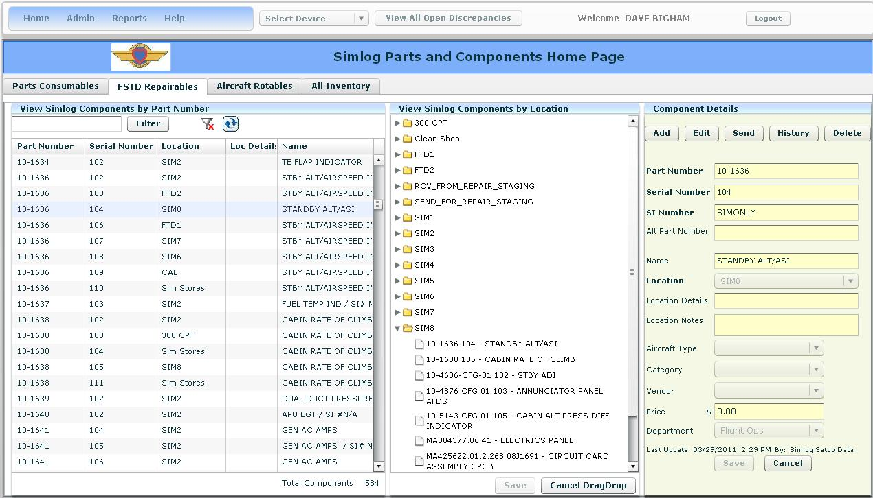

Once the Component Details pane has been populated:

Select Edit to change information. All fields are editable except SI Number, which is fixed as SIMONLY for FSTD Repairables. Typically, only the Location field will be changed, to reflect removing the Component from the FSTD and replacing it with one from Simulator Stores.

If a component is to be sent to an outside vendor for repair:

Locate the component and select it, populating the Component Details view.

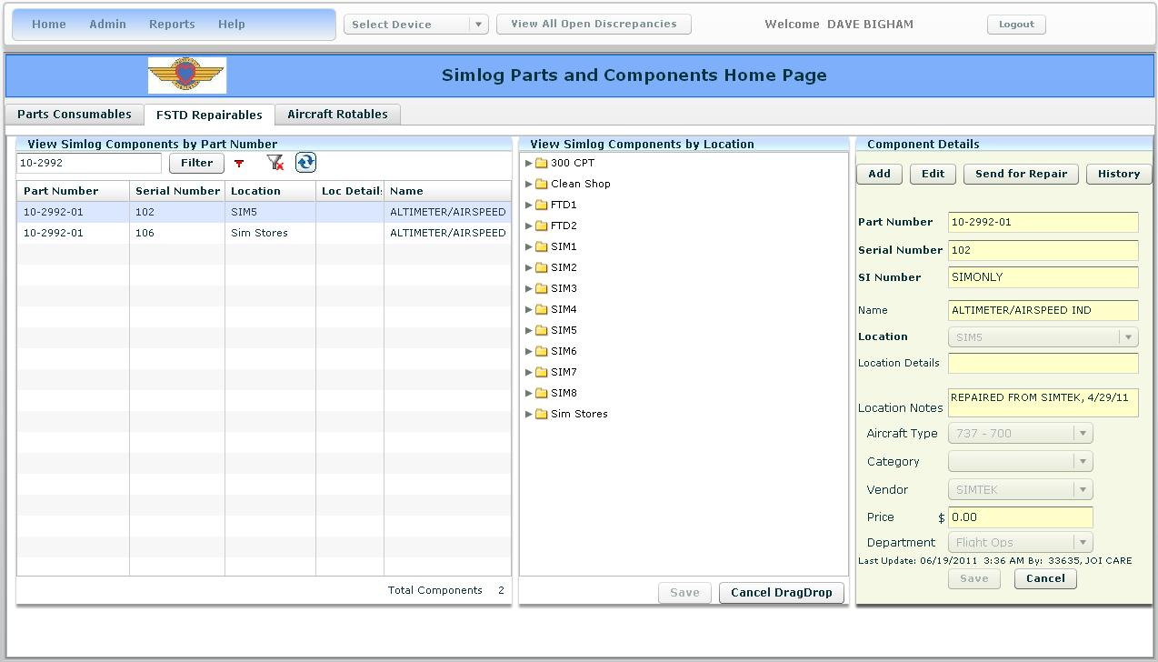

Select the Send button.

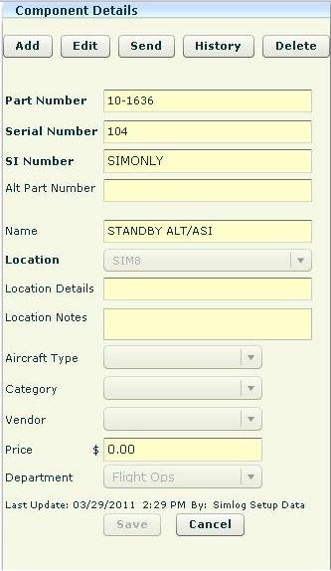

Selecting the Send button will “move” the component from the normal stock inventory to the Out for Repair inventory. The item location will now indicate “SEND_FOR_REPAIR_STAGING” and the component details are no longer editable until it has completed the repair cycle.

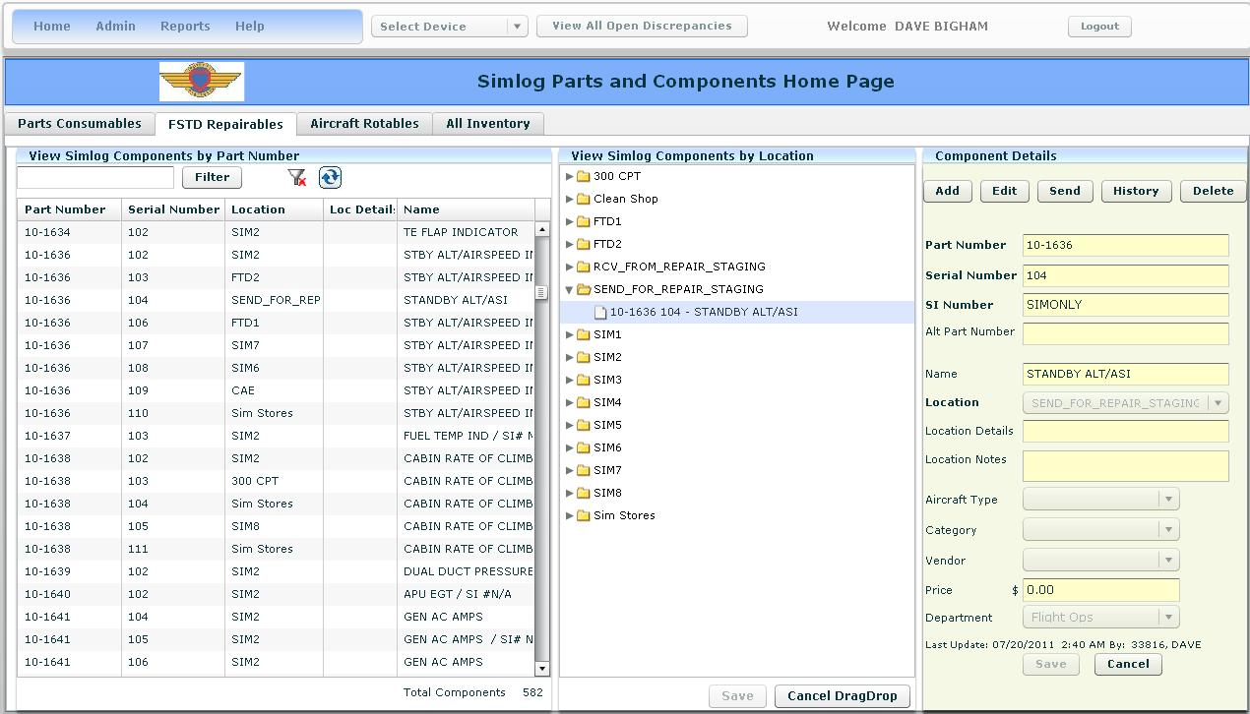

The component can now be found in the Admin>Component Repair view.

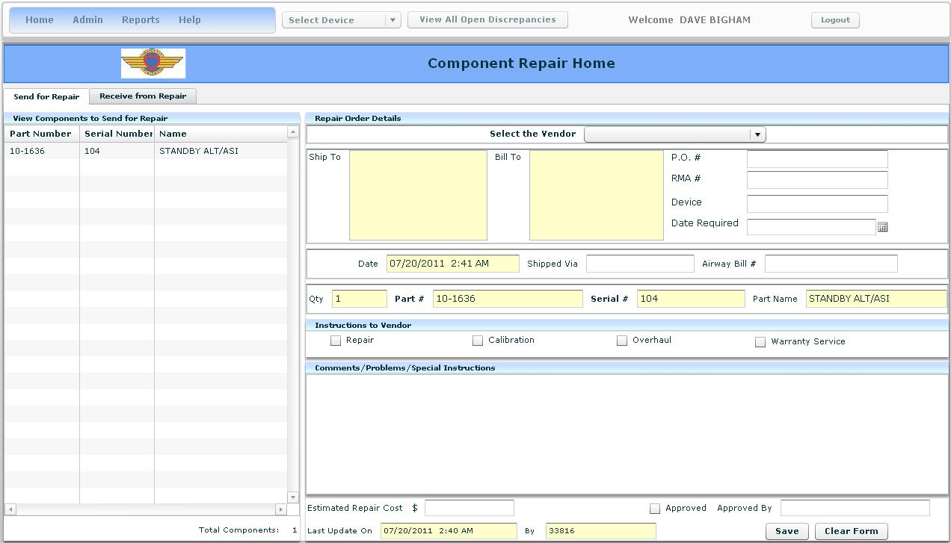

From here, the Admin Coordinator will select a vendor, fill in the details and select save. This transfers the component from the Send for Repair view and to the Receive from Repair.

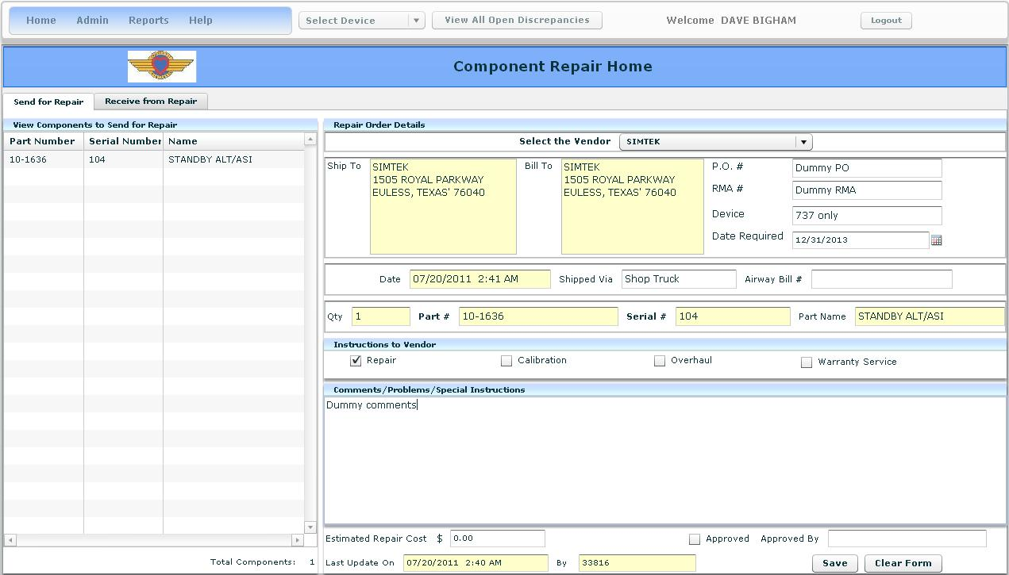

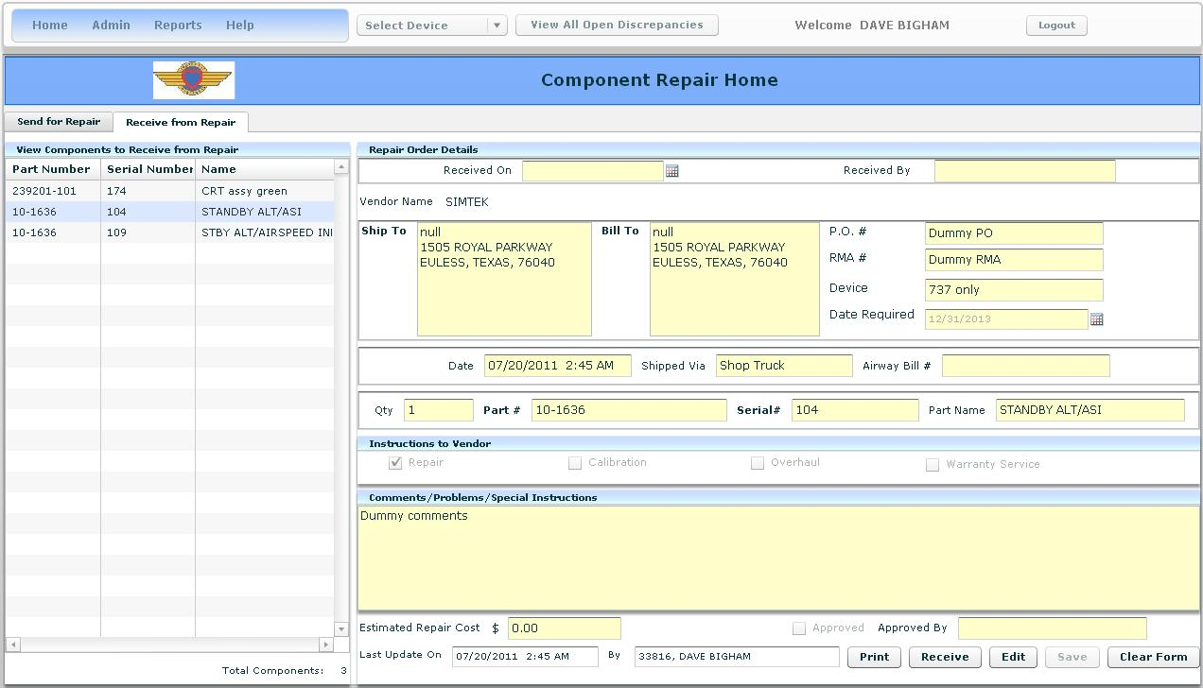

Once the repaired component has been returned, the Admin Coordinator will process the associated paperwork, locate the component in the Receive from Repair view and select the receive button. This will move the component from the out for repair inventory and back into normal stock. The location “RCV_FROM_REPAIR_STAGING” will now appear in the FSTD Repairable view and the component will now be open for edit. Select the component and “place” it into the corresponding physical location.

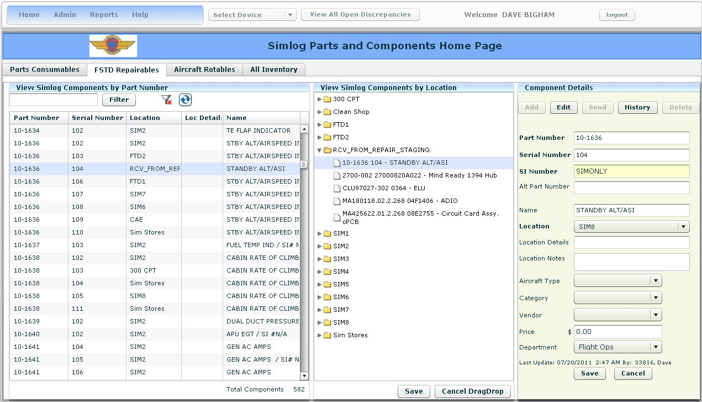

Note: if a Component is “Sent for Repair”, you will not be prompted to replace it with another Component. Don’t forget to track the Component used to replace the failed one.

Components that are classified as Aircraft Rotables will be handled in the same fashion, but the send button will now move the component from the previous location to Maintenance Stores.

Once a component has been physically returned to stores, the record can be deleted from the database.

Any Aircraft Rotable component issued from stores will need to be added into the database. To help with the confusion factor, please keep part number and part names consistent with those found on the stores paperwork.